What's On @ St Michael's  September 2003  St Michael & All Angels Parish Church • High Street • Shefford • Bedfordshire • UK  Website: www.sm3a.org.uk | 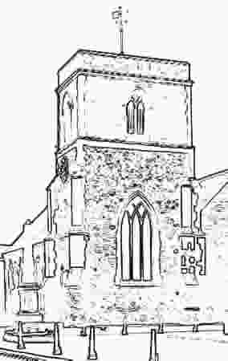

Wednesday 3 Sept | 10 a.m. till 11 a.m. | MINI-M: worship and fun for babies and toddlers (0s-4s) with their parents/minders
Friday 5 Sept | 9.50 a.m. | Holy Communion (Revd David Smith)
Friday 5 Sept | 10.35-12.00 | Tea/coffee served: prayer ministry available
Sunday 7 Sept | 10 a.m. | Family Service (Jenny Dann)
Sunday 7 Sept | 2.30 p.m. | Holy Communion at The Birches (Revd Christine Eagger)
Sunday 7 Sept | 6 p.m. | Evensong at St Mary's Meppershall (Jenny Dann)
Friday 12 Sept | 9.50 a.m. | Holy Communion (Very Revd John Morley)
Friday 12 Sept | 10.35-12.00 | Tea/coffee served: prayer ministry available
Saturday 13 Sept | 10 a.m. to 6 p.m. | Bedfordshire & Hertfordshire Historic Churches Trust SPONSORED BICYCLE RIDE (details in church or contact Ian Mercer on 812682)
Sunday 14 Sept | 11 a.m. | ST MARY'S MEPPERSHALL PATRONAL FESTIVAL Sung Eucharist (Bishop of Bedford)
Sunday 14 Sept | 6 p.m. | Holy Communion
Friday 19 Sept | 9.50 a.m. | Morning Prayer (Jenny Dann)
Friday 19 Sept | 10.35 a.m.-12.00 | Tea/coffee served: prayer ministry available
Sunday 21 Sept | 10.00-11.00 | Messengers group for 3s to 9s (The Tower of Babel)
Sunday 21 Sept | 10.30 a.m. | Family Communion (Revd David Smith)
Sunday 21 Sept | 2.30 p.m. | Ecumenical service at The Birches
Friday 26 Sept | 9.50 a.m. | Holy Communion (Very Revd John Morley)
Friday 26 Sept | 10.35-12.00 | Tea/coffee served: prayer ministry available
Sunday 28 Sept | 10.00 - 11.00 | Thinking Together - St Michael & All Angels Day (Jenny Dann)
Tuesday 30 Sept | 7.30 p.m. | HEALING & WHOLENESS SERVICE with prayer ministry @ Shefford Methodist Church (Shefford Churches Working Together)

Looking Forward to October…
Wednesday 1 Oct | 10 a.m. till 11 a.m. | MINI-M: worship and fun for babies and toddlers (0s-4s) with their parents/minders
Wednesday 1 Oct | 8 p.m. | PEACETALK: four-part learning and discussion workshop on peace issues (1) A 'Just War' - is it possible? What are the criteria? Who decides? (For information contact Jenny Dann on 817337)
Friday 3 Oct | 9.50 a.m. | Holy Communion (Very Revd John Morley)
Friday 3 Oct | 10.35 a.m.-12.00 | Tea/coffee served: prayer ministry available
Saturday 4 Oct |  | PEACETALK EXTRA: Day trip to London (Amos Trust) to meet Bishop Riah Abu el Assal, Anglican Bishop of Jerusalem (For information contact Jenny Dann on 817337)
Sunday 5 Oct | 10 a.m. | Harvest Festival Family Service, with Baptisms (Tinned/packet/dry goods for Christian Family Care)
Sunday 5 Oct | 12.30 p.m. | Bring-And-Share Harvest Lunch
Sunday 5 Oct | 2.30 p.m. | Holy Communion at The Birches (Jenny Dann)
Sunday 5 Oct | 6 p.m. | Evensong at St Mary's Meppershall (Jenny Dann)

Regular Events
Every Tuesday (except following Bank Holidays) 10.15 - 12.00 - Coffee Shop run by the Biggleswade Adult Centre
- PLUS -
Time - 4 - U If you need someone to talk to (in confidence), we have the listeners available

Reader (Licensed Lay Minister): Jenny Dann 01462 817337
Churchwardens: Stuart Brayne 01462 815689
Ian Mercer 01462 812682

