What's On @ St Michael's  October 2003  St Michael & All Angels Parish Church • High Street • Shefford • Bedfordshire • UK  Website: www.sm3a.org.uk | 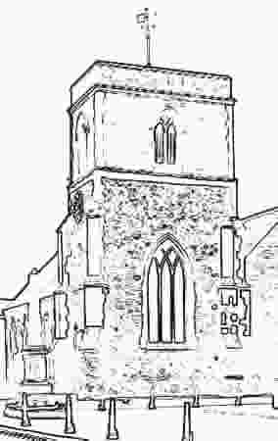

Wednesday 1 Oct | 10 a.m. till 11 a.m. | MINI-M: worship and fun for babies and toddlers (0s-4s) with their parents/minders
Wednesday 1 Oct | 8 p.m. | PEACETALK: four-part learning and discussion workshop on peace issues (1) A 'Just War' - is it possible? What are the criteria? Who decides? (For information contact Jenny Dann on 817337)
Friday 3 Oct | 9.50 a.m. | Holy Communion (Revd John Cuthbert)
Friday 3 Oct | 10.35-12.00 | Tea/coffee served : prayer ministry available
Saturday 4 Oct | PEACETALK EXTRA: Day trip to London (Amos Trust) to meet Bishop Riah Abu el Assal, Anglican Bishop of Jerusalem (For information contact Jenny Dann on 817337)
Sunday 5 Oct | 10.30 a.m. | Harvest Festival Family Service, with Baptisms (Tinned/packet/dry goods for Christian Family Care)
Sunday 5 Oct | 12.30 p.m. | Bring-And-Share Harvest Lunch
Sunday 5 Oct |  | (No service at The Birches today)
Sunday 5 Oct | 6 p.m. | Evensong at St Mary's Meppershall (Jenny Dann)
Tuesday 7 Oct | 2.30 p.m. | Church meeting (formerly MU) - speaker Revd Steve Summerfield. All welcome.
Wednesday 8 Oct | 8 p.m. | PEACETALK: four-part learning and discussion workshop on peace issues (2) The Pacifists - who are/were they? Is pacifism a realistic option? (For information contact Jenny Dann on 817337)
Friday 10 Oct | 9.50 a.m. | Holy Communion (Very Revd John Morley)
Friday 10 Oct | 10.35-12.00 | Tea/coffee served : prayer ministry available
Sunday 12 Oct | 10 a.m. | Morning Prayer (Jenny Dann)
Sunday 12 Oct | 6 p.m. | Holy Communion (Very Revd John Morley)
Wednesday 15 Oct | 8 p.m. | PEACETALK: four-part learning and discussion workshop on peace issues (3) Human Rights - what do they mean? How do they affect our lives and attitudes? (For information contact Jenny Dann on 817337)
Friday 17 Oct | 9.50 a.m. | Morning Prayer (Jenny Dann)
Friday 17 Oct | 10.35-12.00 | Tea/coffee served : prayer ministry available
Sunday 19 Oct | 9.30-10.30 | Messengers group for 3s to 9s
Sunday 19 Oct | 10 a.m. | Family Communion (Revd Rupert Child)
Sunday 19 Oct | 2.30 p.m. | Ecumenical service at The Birches
Wednesday 22 Oct | 8 p.m. | PEACETALK: four-part learning and discussion workshop on peace issues (4) Are We Peacemakers? - facing the challenge, making a difference (For information contact Jenny Dann on 817337)
Friday 24 Oct | 9.50 a.m. | Holy Communion (Revd David Smith)
Friday 24 Oct | 10.35-12.00 | Tea/coffee served : prayer ministry available
Sunday 26 Oct | 10 a.m. | Thinking Together (Jenny Dann)
Sunday 26 Oct | 4.30 p.m. | Tea & Bible Exhibition
Sunday 26 Oct | 6 p.m. | Bible Sunday United Service (Shefford Churches Working Together)
Friday 31 Oct | 9.50 a.m. | Holy Communion (Very Revd John Morley)

Regular Events
Every Tuesday (except following Bank Holidays) 10.15 - 12.15 - Coffee Shop run by the Biggleswade Adult Centre
- PLUS -
Time - 4 - U If you need someone to talk to (in confidence), we have the listeners available

Reader (Licensed Lay Minister): Jenny Dann 01462 817337
Churchwardens: Stuart Brayne 01462 815689
Ian Mercer 01462 812682

