What's On @ St Michael's  August 2003  St Michael & All Angels Parish Church • High Street • Shefford • Bedfordshire • UK  Website: www.sm3a.org.uk | 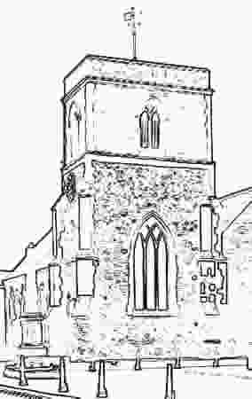

Friday 1 August | 9.50am | Holy Communion (Very Revd John Morley)
Friday 1 August | 10.35-12.00 | Tea/coffee served: prayer ministry available
Sunday 3 August | 10am | Summer Special Family Service  (Jenny Dann)  Angel Stories (1) Stairway to Heaven
Sunday 3 August | 2.30pm | Holy Communion at The Birches (Jenny Dann)

4-8 August | daily from  2.30-4.15pm | ANGELMAS:  Help create a new musical in 5 days!  All-age workshops-songs/drama/art/dance  -follow Michael the Archangel in the Great Battle for Heaven!  For details contact Jenny Dann on 01462 817337  OR log on to the website www.sm3a.org.uk
Wed 6 August | 10am till 11am  doors open @ 9.30 | MINI-M: worship and fun for babies and toddlers  (0s-4s) with their parents/minders  TEDDY BEARS' PICNIC  -bring a teddy and a snack  -older children also welcome!
Friday 8 August | 9.50am | Holy Communion (Very Revd John Morley)
Friday 8 August | 10.35-12.00 | Tea/coffee served: prayer ministry available
Sunday 10 August | 10am | Summer Special Morning Prayer  (Jenny Dann)  Angel Stories (2) The Donkey Speaks
Sunday 10 August | 6pm | Holy Communion (Revd Alan Bliss)

Friday 15 August | 9.50am | Morning Prayer (Jenny Dann)
Friday 15 August | 10.35-12.00 | Tea/coffee served : prayer ministry available
Sunday 17 August | 10am | Summer Special Family Communion  (Revd Christine Eagger)  Angel Stories (3) Food for the Journey
Sunday 17 August | 12.30 for 1pm | BRING & SHARE LUNCH
Sunday 17 August | 2.30pm | Ecumenical Service at The Birches

Friday 22 August | 9.50am | Holy Communion (Revd John Cuthbert)
Friday 22 August | 10.35-12.00 | Tea/coffee served : prayer ministry available
Sunday 24 August | 10am | Summer Special Thinking Together  (Jenny Dann)  Angel Stories (4) Promises, Promises!

Friday 29 August | 9.50am | Holy Communion (Revd Alan Bliss)
Sunday 31 August | 9am | Feast on 5 Breakfast (shared with St Mary's, Meppershall)
Sunday 31 August | 10am | Summer Special Service  (Jenny Dann + Ben Griffith-to be confirmed)  Angel Stories (5) Release from Prison

Looking forward to September…
Wednesday 3 Sept | 10am till 11am | MINI-M: worship and fun for babies and toddlers  (0s-4s) with their parents/minders
Friday 5 Sept | 9.50am | Holy Communion
Friday 5 Sept | 10.35-12.00 | Tea/coffee served : prayer ministry available
Sunday 7 Sept | 10am | Family Service
Sunday 7 Sept | 2.30pm | Holy Communion at The Birches (Revd Christine Eagger)

Regular Events
Every Tuesday (except following Bank Holidays) 10.15 - 12.00 - Coffee Shop run by the Biggleswade Adult Centre
- PLUS -
Time - 4 - U If you need someone to talk to (in confidence), we have the listeners available

Reader (Licensed Lay Minister): Jenny Dann 01462 817337
Churchwardens: Stuart Brayne 01462 815689
Ian Mercer 01462 812682

